Answers to the questions:

1. Can you smooth out the regime switches by adding a moving average?

* For now, the data is already smoothed by a 3-month moving average. Our goal is then to change the length of the rolling window (2,4, 5, 6, … months) to see which one performs better.

1. At what moving average does the strategy have the best Sharpe Ratio?

| Moving Avg | 2-month | 3-month | 4-month | 5-month | 6-month |
| --- | --- | --- | --- | --- | --- |
| Sharpe Ratio | 1.21 | 1.17 | 1.13 | 1.06 | 1.03 |

* We obtain a decreasing trend in the Sharpe Ratio as the number of months increases. Thus, a 2-month rolling window for the moving average is the best choice.

1. Can you check how the strategy performed after December 1972?

* The strategy changes for 1972~2024 data:

| Regime | 1872~2024 Objective | 1972~2024 Objective |
| --- | --- | --- |
| 1 | maximize sharpe ratio | maximize sharpe ratio |
| 2 | minimize variance | minimize variance |
| 3 | maximize sharpe ratio | minimize variance |
| 4 | minimize variance | maximize sharpe ratio |

* Note that the number of regimes with max sharpe ratio and min variance as objectives does not have to be the same. (i.e., I can set the objective of all three regimes to be max sharpe ratio and one to be min variance, etc.)
* Below is the comparison in sharpe ratio between 1872~2024 data and 1972~2024 data:

|  | 1872~2024 | 1972~2024 |
| --- | --- | --- |
| Sharpe Ratio | 1.21 | 1.62 |

Conclusion:

1. We will change the moving average from a 3-month rolling window to a 2-month rolling window.
2. We change the 1872~2024 data to 1973~2024.

Input data

|  | G/I | Start date | Frequency | End date |
| --- | --- | --- | --- | --- |
| inflation | Inflation | 1872-01-01 | monthly | 2024-09-01 |
| S&P 500 | Growth | 1871-01-01 | monthly -> daily | 2024-10-29 |

Output data

|  | Start date | Frequency | End date |
| --- | --- | --- | --- |
| bonds | 1793-01-01 | monthly -> daily | 2024-09-24 |
| gold | 1792-12-31 | yearly -> daily | 2024-09-26 |
| S&P 500 | 1871-01-01 | monthly -> daily | 2024-10-29 |

Pre-processing

1. Aligned the start and end dates to 1973-01-01 ~ 2024-09-01
2. Get the monthly data (first day of each month)
3. Calculate 2-months simple moving average
4. Calculate first derivative
5. Define Regimes based on

| Regime | G’ | I’ | G | I |
| --- | --- | --- | --- | --- |
| 1 | > 0 | > 0 | Rising | Rising |
| 2 | > 0 | <= 0 | Rising | Falling |
| 3 | <= 0 | > 0 | Falling | Rising |
| 4 | <= 0 | <= 0 | Falling | Falling |

1. Finalized data: 1973-01-01 ~ 2024-09-01; monthly data

Visualization

1. When was which regime?

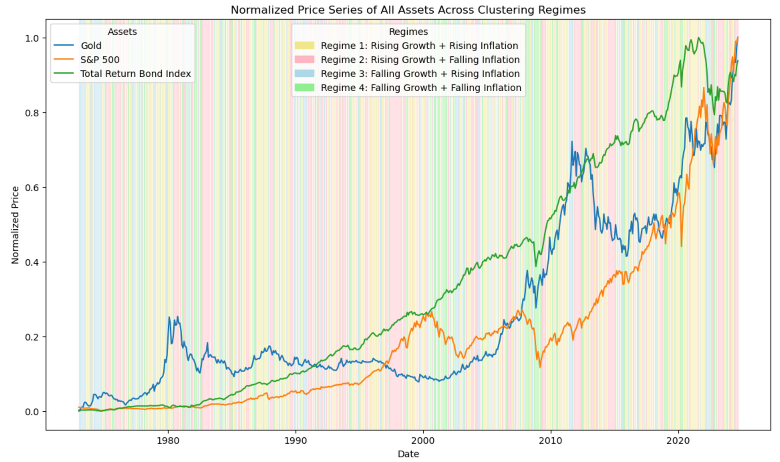

1. y-axis return; x-axis asset class plot

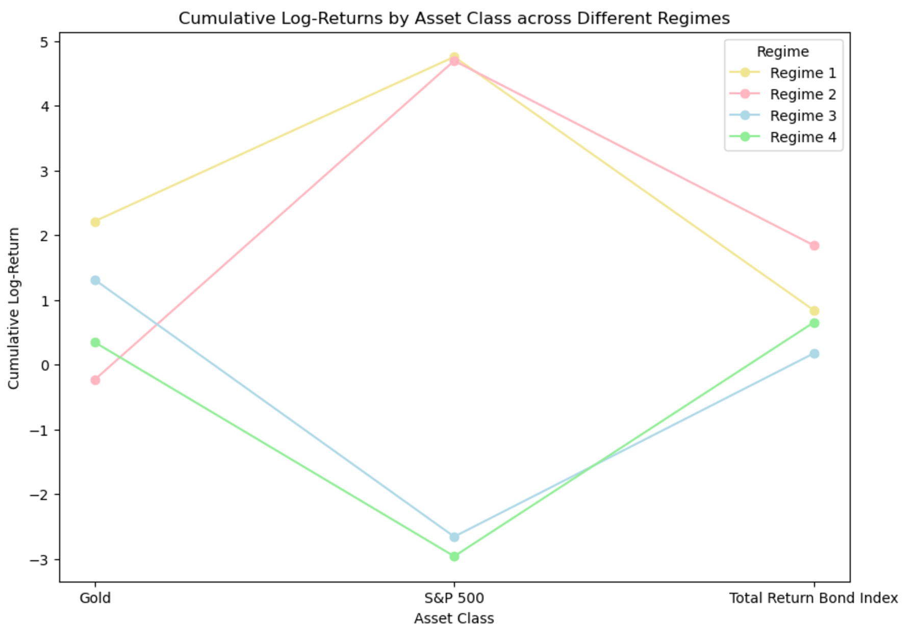

1. Asset Performance Metrics per Regime

| Average Return | | | |
| --- | --- | --- | --- |
| Regime | Gold | S&P 500 | Bonds |
| 1 | **769** | **1321** | **1437** |
| 2 | 724 | 1174 | 125 |
| 3 | 545 | 887 | 992 |
| 4 | 710 | 1135 | 1298 |

| Volatility | | | |
| --- | --- | --- | --- |
| Regime | Gold | S&P 500 | Bonds |
| 1 | 578 | 1281 | 1149 |
| 2 | **590** | **1257** | **1046** |
| 3 | 486 | 1040 | 993 |
| 4 | 540 | 1108 | 1040 |

| Sharpe Ratio | | | |
| --- | --- | --- | --- |
| Regime | Gold | S&P 500 | Bonds |
| 1 | 1.33 | 1.03 | 1.25 |
| 2 | 1.23 | 0.93 | 1.20 |
| 3 | 1.12 | 0.85 | 1.00 |
| 4 | **1.31** | **1.02** | **1.25** |

| Max Drawdown | | | |
| --- | --- | --- | --- |
| Regime | Gold | S&P 500 | Bonds |
| 1 | -0.62 | -0.47 | -0.18 |
| 2 | -0.61 | -0.42 | -0.16 |
| 3 | -0.49 | -0.43 | -0.15 |
| 4 | -0.49 | -0.52 | -0.17 |

Portfolios Optimization

Strategy:

1. Based on the performance above, Regime 1,4 have higher sharpe ratios, Regime 3 have lower returns, and Regime 2 has high volatility but medium returns, so our objective for each regime is:

| Regime | Objective |
| --- | --- |
| 1 | maximize Sharpe ratio |
| 2 | minimize variance |
| 3 | minimize variance |
| 4 | maximize Sharpe ratio |

1. Dynamic Portfolio Weights for each Regime

| Regime | Gold | S&P 500 | Bonds |
| --- | --- | --- | --- |
| 1 | 30.33% | 23.02% | 46.65% |
| 2 | 1.75% | 20.05% | 78.20% |
| 3 | 24.52% | 0% | 75.48% |
| 4 | 8.71% | 3.46% | 87.83% |

1. Comparison between Benchmark (S&P 500) and Dynamic Portfolio Optimization

|  | Benchmark | Regime-Based Portfolio |
| --- | --- | --- |
| Annual Volatility | 15.88% | 17.44% |
| Sharpe Ratio | 0.44 | 1.62 |
| Sortino Ratio | 0.59 | 3.82 |
| Max Drawdown | -54.70% | -35.35% |

|  | Portfolio vs Benchmark |
| --- | --- |
| Annual Excess Return | 21.33% |
| Tracking Error | 23.60% |
| Information Ratio | 0.90 |

1. Visualization

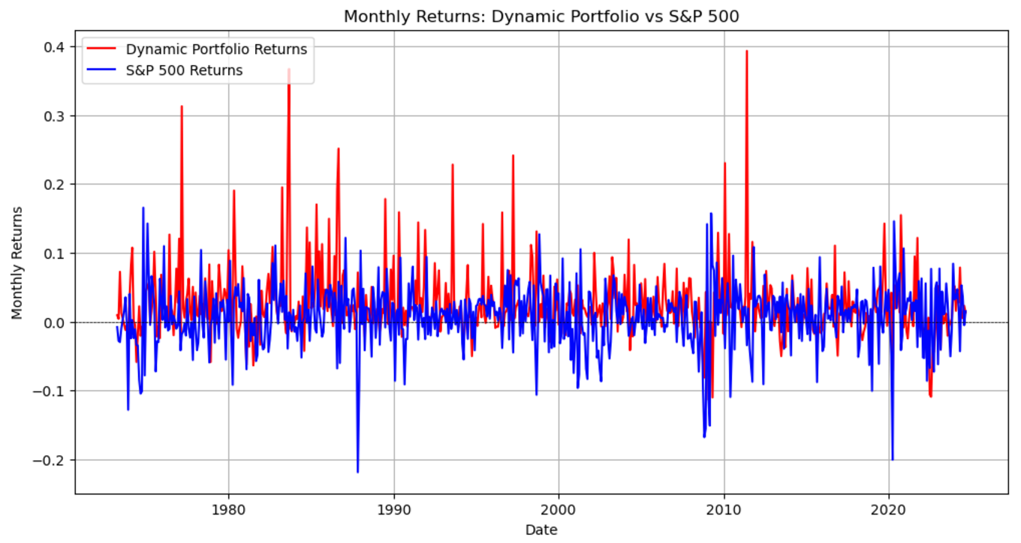

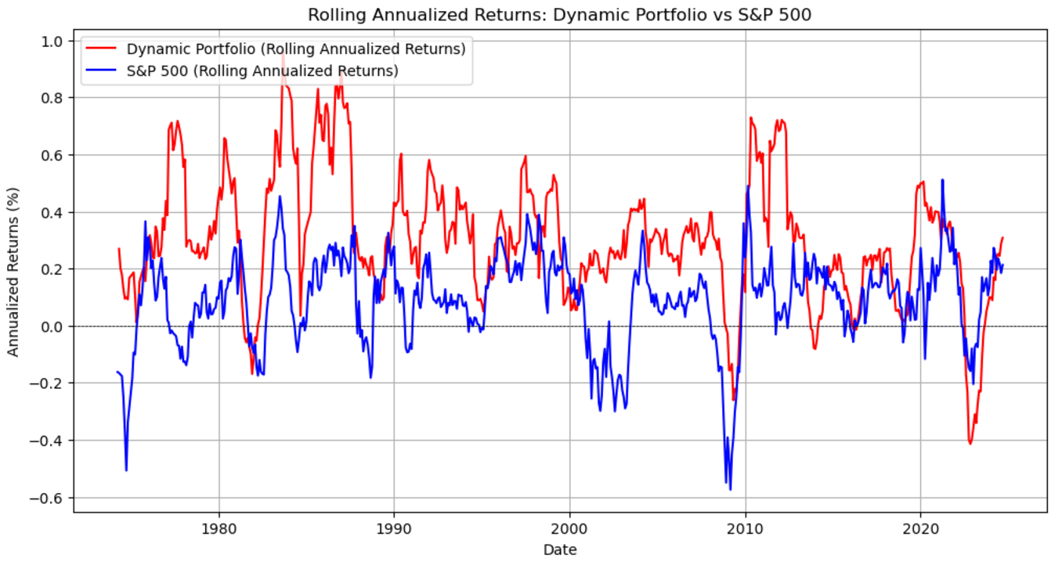

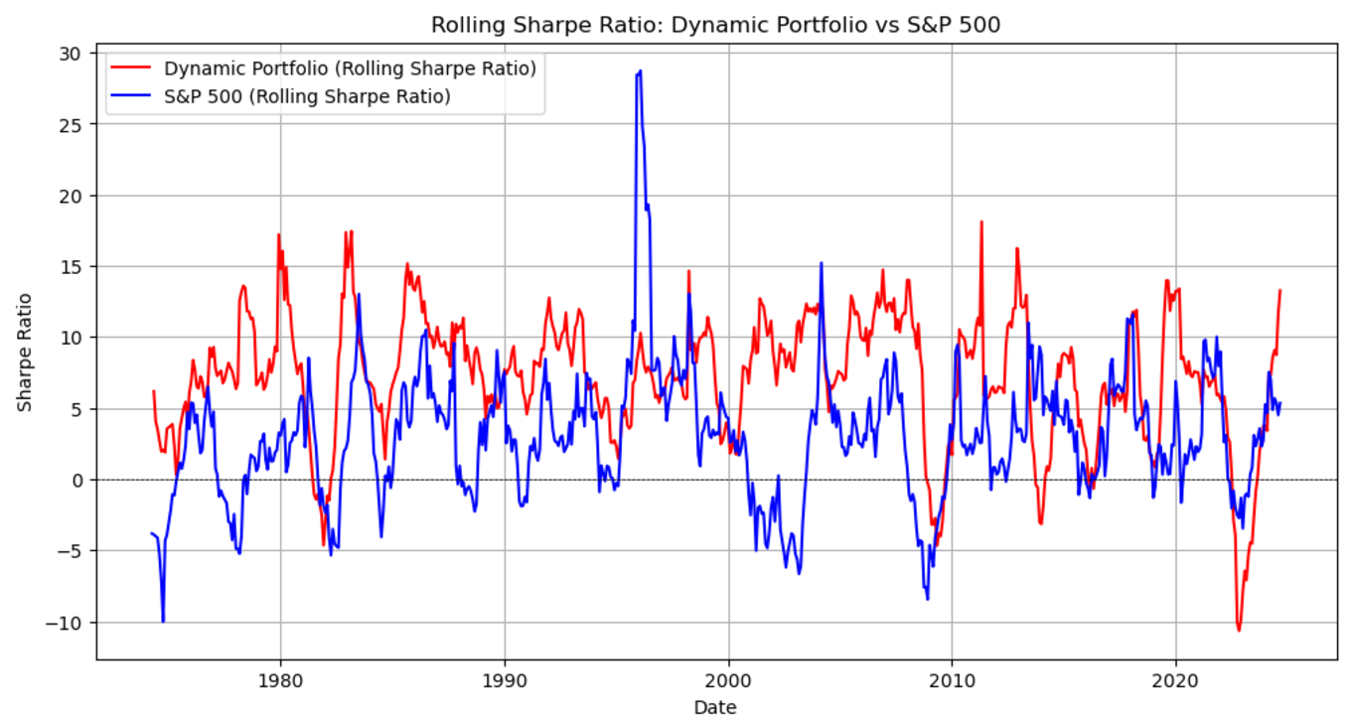

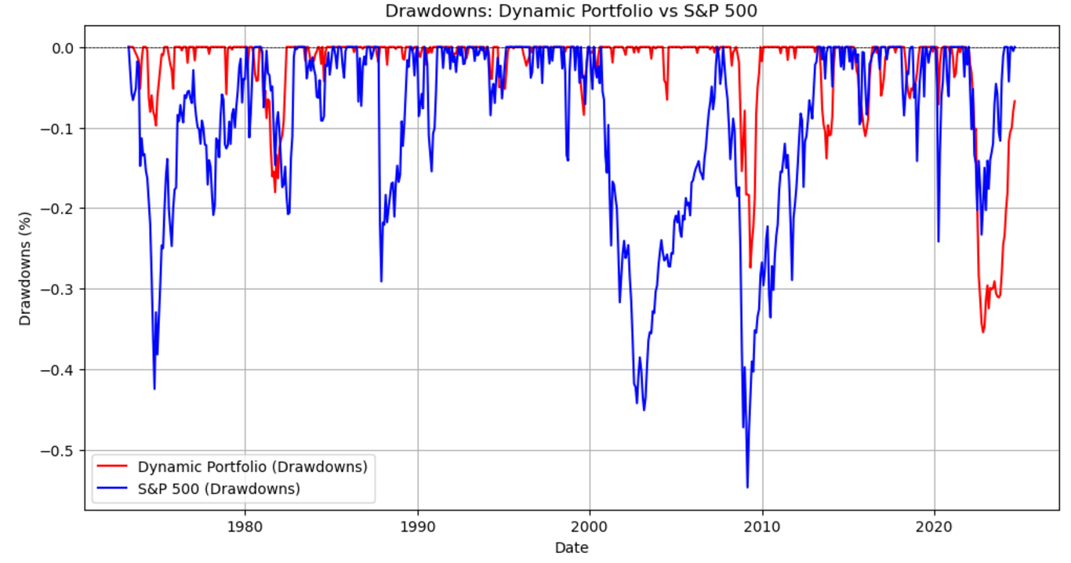

Limitations & Recommendations:

Data:

* We used monthly data rather then daily data, which loses some of the information
  + can change to the daily data in the future
* Use only S&P 500 and inflation data, cannot reflect the real market
  + can add other inputs in the future

Method: (the model)

* Only set objective function but have no constraints
  + can add constraints to the model according to investors’ ideas
    - prior knowledge needed

Financial concepts:

* the model is only an ideal case; according to the "when was which regime" graph, regime-switching was very frequent, which means that high-frequency trading is required to achieve the desired return
  + however, in the real world, one also needs to be aware of trading transaction fees and other potential charges (?)

Conclusion

We first defined four regimes based on the rising/falling of growth and inflation. Then, based on the asset performance for each regime, we set objectives separately for each regime. Finally, using a dynamic strategy, we had an optimization model. By comparison with the benchmark, our model performs better in every indicator.